**DAILY ONLINE ACTIVITIES SUMMARY**

|  |  |  |  |  |  |  |  |
| --- | --- | --- | --- | --- | --- | --- | --- |
| **Date:** | **17-6-2020** | | | | **Name:** | **Harshitha M** | |
| **Sem & Sec** | **8th sem A sec** | | | | **USN:** | **4al16cs038** | |
| **Online Test Summary** | | | | | | | |
| **Subject** | | **-** | | | | | |
| **Max. Marks** | | **-** | | **Score** | | **-** | |
| **Certification Course Summary** | | | | | | | |
| **Course** | **Introduction to cyber security** | | | | | | |
| **Certificate Provider** | | | **Great learning academy** | **Duration** | | | **5.5hr** |
| **Coding Challenges** | | | | | | | |
| **Problem Statement:**  **1.** **C program to replace all 0’s with 1 in a given integer** | | | | | | | |
| **Status:completed** | | | | | | | |
| **Uploaded the report in Github** | | | | **yes** | | | |
| **If yes Repository name** | | | | **Harshitha-M** | | | |
| **Uploaded the report in slack** | | | | **yes** | | | |

**Online test**

-----------not conducted-----------

**Certification course**

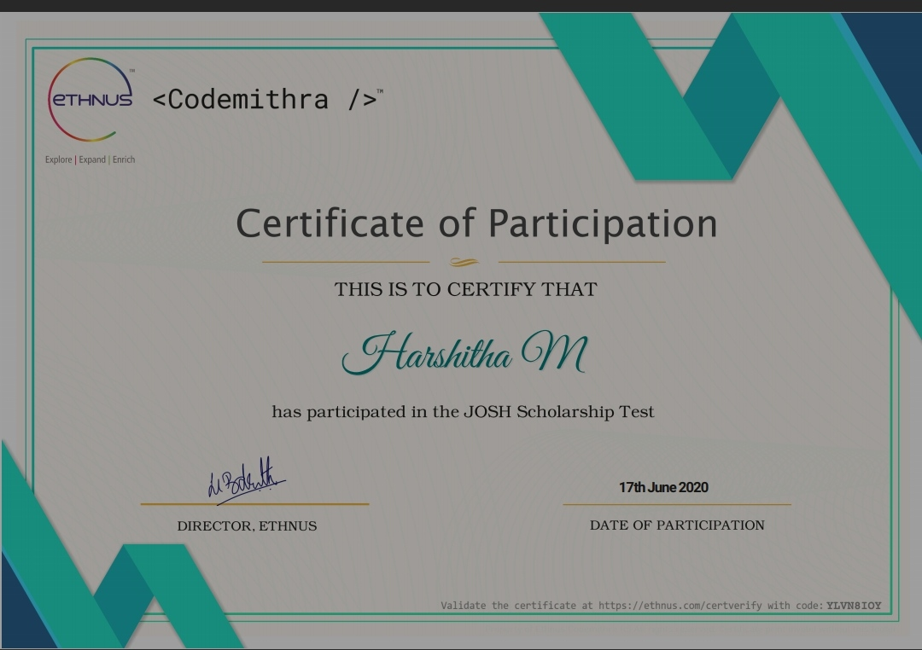

**Coding**

**Program 1**

// C program to replace all 0’s with 1 in a given integer

#include

int replace (**long** int num)

{

// Base case for recursion termination

if (num == 0)

return 0;

// Extract the last digit and change it if needed

int digit = num % 10;

if (digit == 0)

digit = 1;

// Convert remaining digits and append the last digit

return replace(num/10) * 10 + digit;

}

int Convert(**long** int num)

{

if (num == 0)

return 1;

else

return replace(num);

}

int main()

{

**long** int num;  
 //To take user input

printf("\nInsert the num : ");

scanf("%d", &number);

//display final result  
 printf("\n Num after replacement : %d\n", Convert (num));

return 0;

}